**MATHEMATICS SPECIALIST 3 & 4 SOLUTIONS**

**Test 1 2017**

**Section One: Calculator-free**

Reading Time: 2 minutes

Time Allowed: 21 minutes Total Marks: 21

1. (3 marks)

Sketch the graph of  on the axes below.



1. (5 marks)
2. Solve the equation . (3 marks)

|  |
| --- |
| **Solution** |
|  |
| **Specific behaviours** |
| ✓ separates into cases  ✓ solves first case  ✓ solves second case |

(b) Solve the inequality . (2 marks)

|  |
| --- |
| **Solution** |
|  |
| **Specific behaviours** |
| ✓ determines correct endpoints  ✓ states correct inequalities |

3. (5 marks)

(a)  (2)

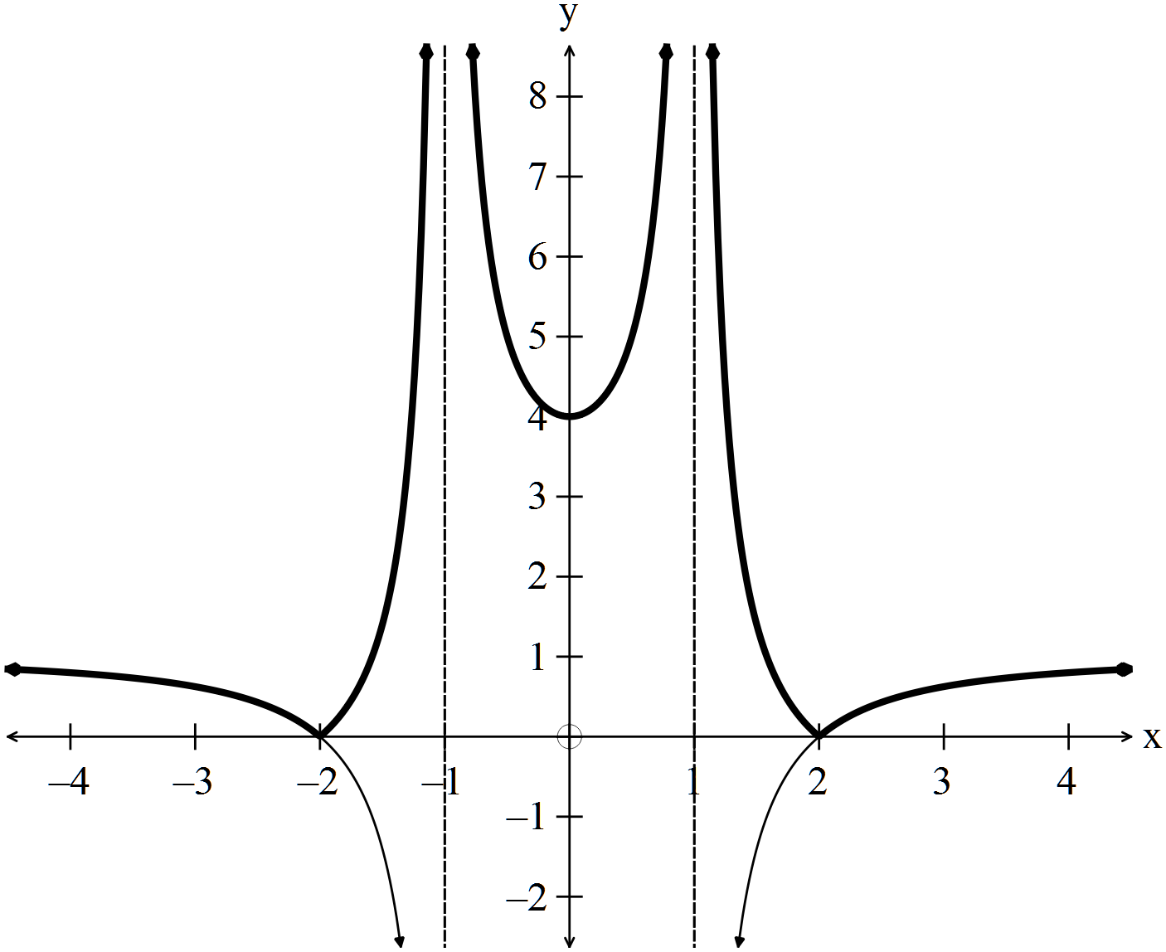

✓

✓

(b)  (3)

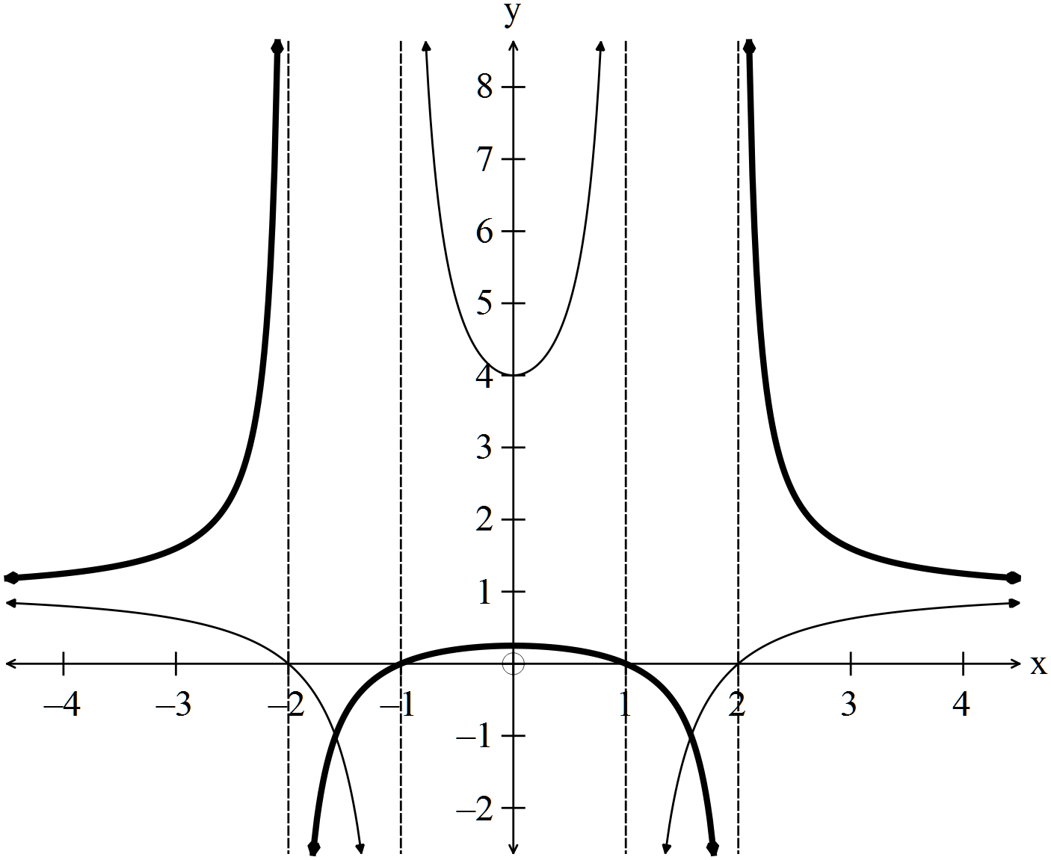

Asymptotes ✓

x-intercepts ✓

shape ✓

4. (8 marks)

The function $f$ is defined as $f\left(x\right)=\frac{x^{2}-1}{x^{2}+1}$.

(a) Show that the **only** stationary point of the function occurs when $x=0$. (2 marks)

|  |
| --- |
| **Solution** |
| $$f^{'}\left(x\right)=\frac{2x\left(x^{2}+1\right)-2x\left(x^{2}-1\right)}{{\left(x^{2}+1\right)}^{2}}=\frac{4x}{{\left(x^{2}+1\right)}^{2}}$$ Hence $f^{'}\left(x\right)=0$ only when $4x=0⇒x=0$. |
| **Specific behaviours** |
| ✓ differentiates function  ✓ simplifies and makes conclusion |

(b) Sketch the graph of $y=f(x)$ on the axes below. (3 marks)

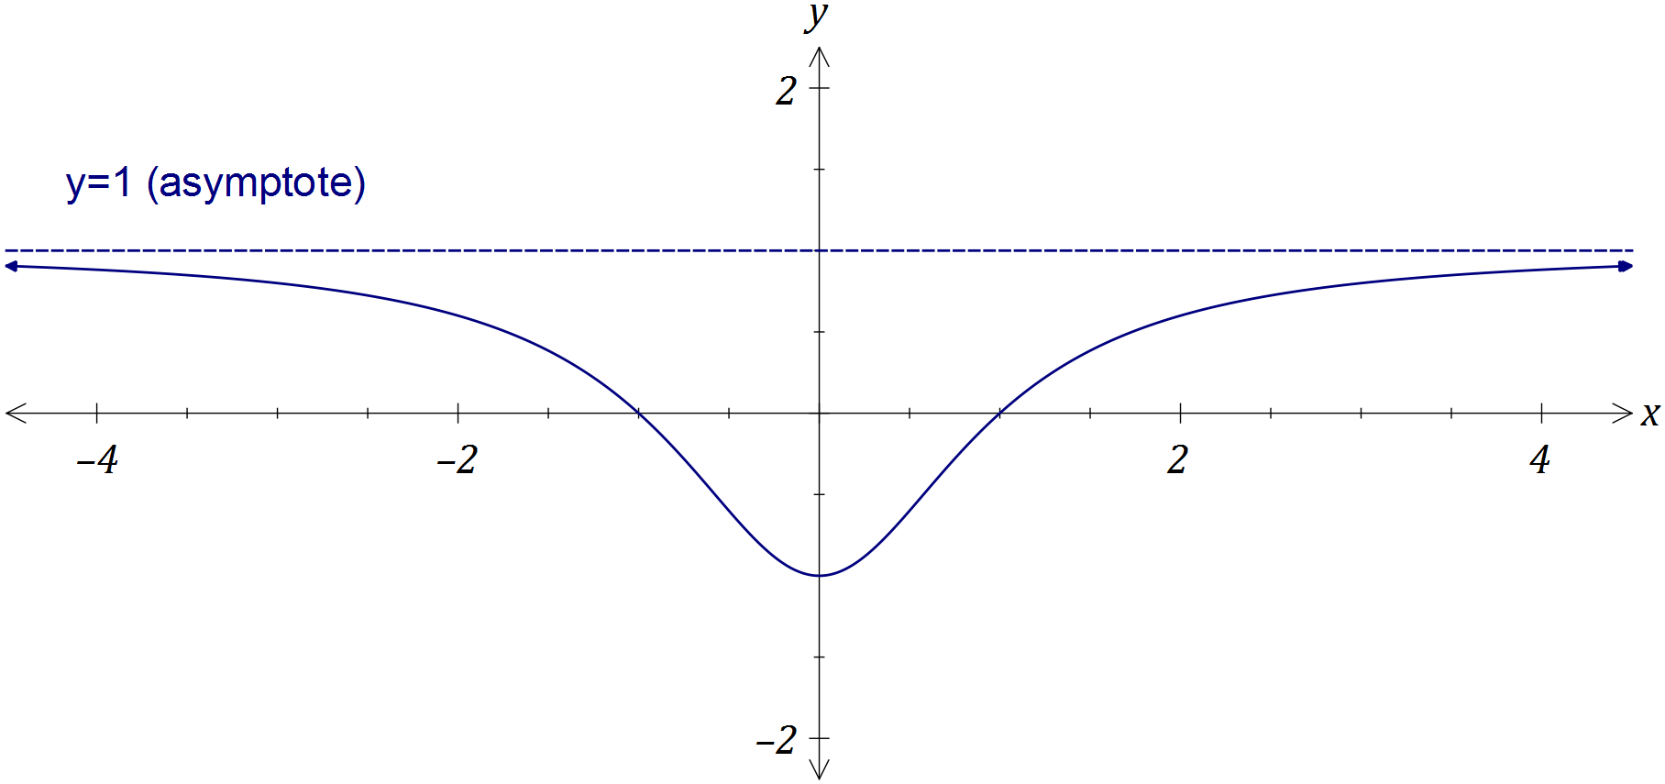

|  |
| --- |
| **Solution** |
| See graph |
| **Specific behaviours** |
| ✓ turning point  ✓ roots  ✓ approaches asymptote from below |

(c) Using your graph, or otherwise, determine all solutions to

(i) $f\left(x\right)=\left|f(x)\right|$. (1 mark)

 ✓

(ii) $f\left(x\right)=f(\left|x\right|)$. (1 mark)

✓

(iii) $f\left(x\right)=\frac{1}{f\left(x\right)}$. (1 mark)

 ✓

**MATHEMATICS SPECIALIST 3 & 4 SOLUTIONS**

**Test 1 2017**

**Section One: Calculator-assumed**

Reading Time: 3 minutes

Time Allowed: 30 minutes Total Marks: 28

5. (5 marks)

Consider the function .

(a) Explain why it is necessary to restrict the natural domain of f in order that its inverse is also a function. (1 mark)

|  |
| --- |
| **Solution** |
| is not a one-to-one function for $x∈R$ |
| **Specific behaviours** |
| ✓ explains function is not one-to-one over natural domain |

(b) State a minimal restriction to the domain of f that includes , and then use this restriction to show that . (4 marks)

|  |
| --- |
| **Solution** |
| f has a turning point at (2, -4) and so minimal restriction is  to include |
| **Specific behaviours** |
| ✓ states minimal restriction to domain that includes  ✓ completes square on RHS, adjusting LHS  ✓ chooses, with reason, +ve root  ✓ states inverse |

6. (6 marks)

Consider the functions  and 

(a) (i) 



✓

✓

(2)

(ii) 

✓

is NOT a one to one function as (eg)  (1)

(b)  (3)

✓✓Working ✓Answer

7. (4 marks)

The graph of  is shown below.

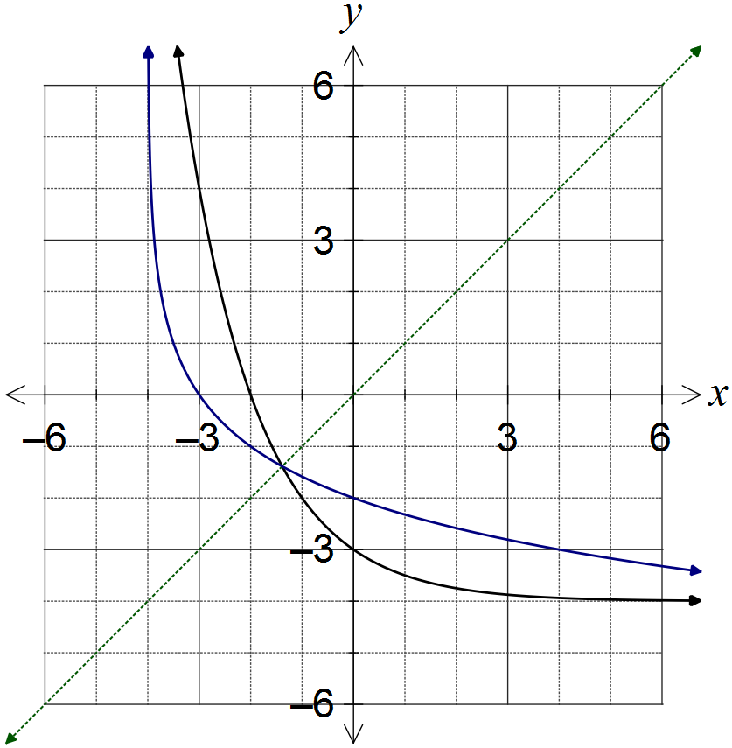

|  |
| --- |
| **Solution** |
| (ii) See diagram |
| **Specific behaviours** |
| ✓ both axes intercepts shown correctly  ✓ curve approaches vertical asymptote  ✓ smooth curve with  as mirror line |

(a) What feature of the graph suggests that the inverse of f is a function? (1 mark)

|  |
| --- |
| **Solution** |
| The part of the graph shown is clearly one-to-one using the horizontal line test. |
| **Specific behaviours** |
| ✓ describes function as one-to-one using graph feature |

(b) On the same axes, sketch the graph of the inverse of f, . (3 marks)

8. (5 marks)

|  |  |
| --- | --- |
| Solution | |
| and  are vertical asymptotes  Graph passes through .  is a point on the graph  Equation of rational function is | |
| Mathematical behaviours | Marks |
| * identifies the two vertical asymptotes * concludes * concludes * determines * writes equation of rational function | 1  1  1  1  1 |

9. (4 marks)

|  |
| --- |
| Solution |
| There are three situations to consider: |

1 mark for each situation

1 mark for determining (0,1)